SafePay FinTech
SafePay FinTech is a secure and user-friendly Streamlit-based application designed to protect financial data through encryption and authentication. The app includes features like user registration, login, password encryption and decryption, and file upload security. It also allows users to safely enter and manage numeric inputs such as amounts or transaction values. With strong password validation, activity tracking, and automatic session handling, SafePay FinTech ensures data privacy, reliability, and a smooth digital experience for every user.
HOME PAGE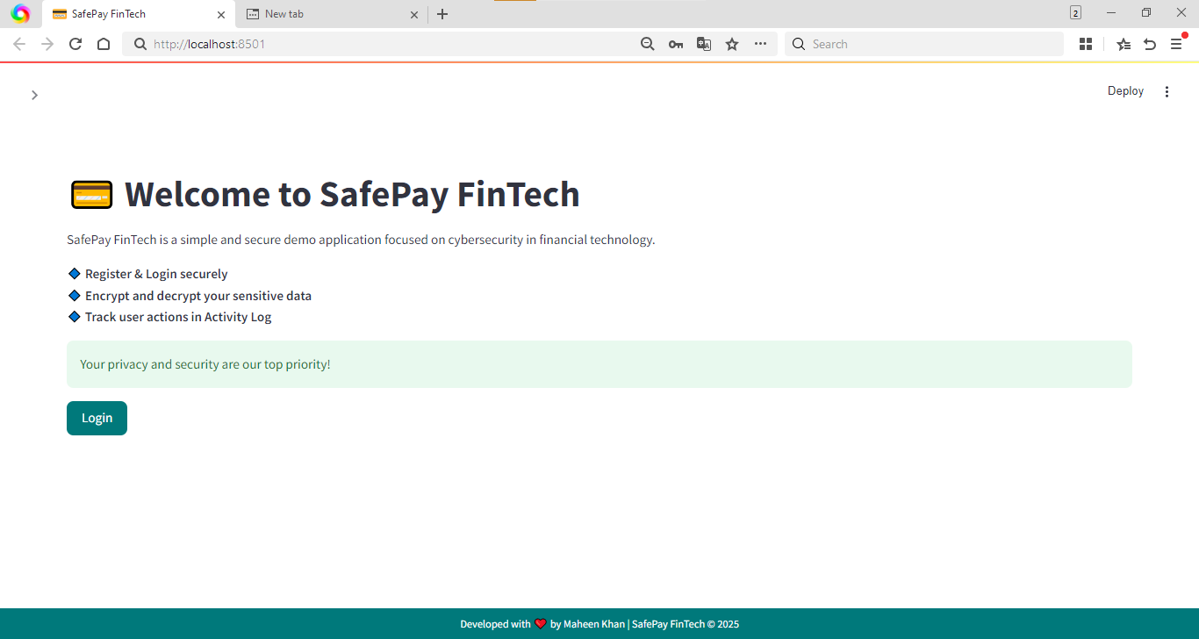REGISTER PAGE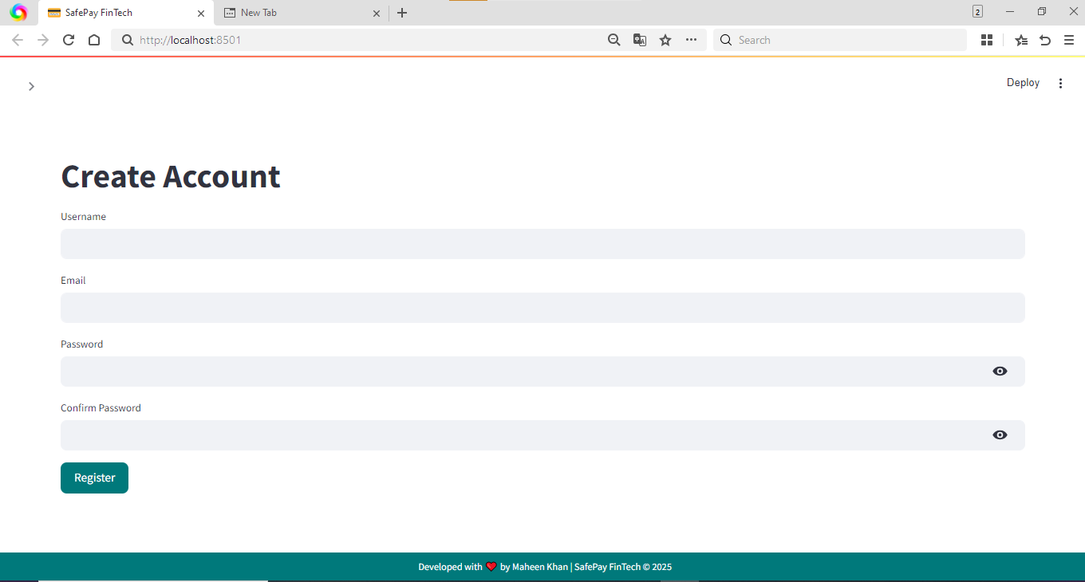

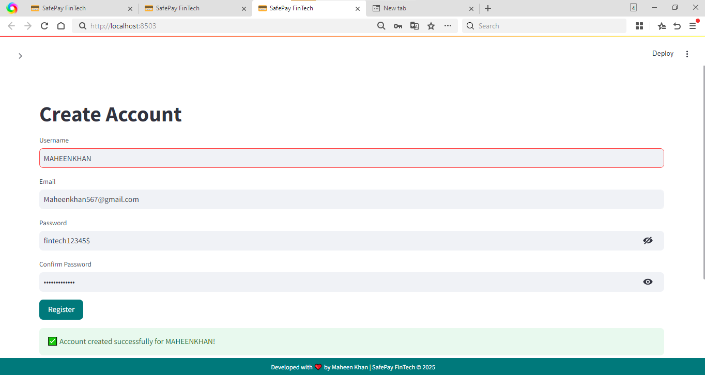

LOGIN PAGE
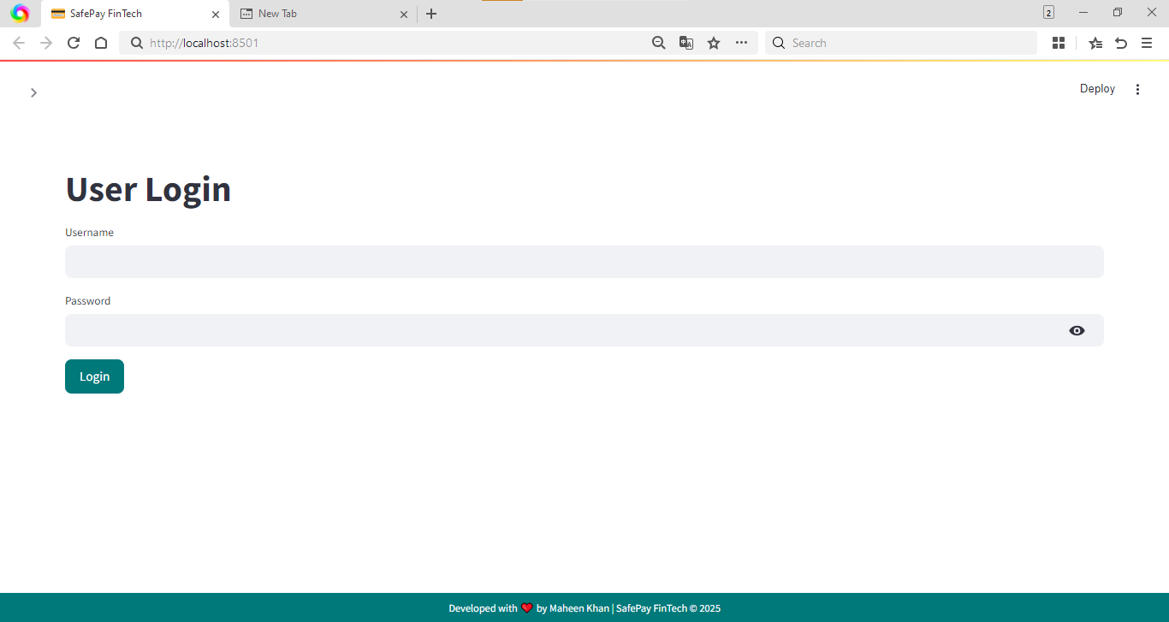
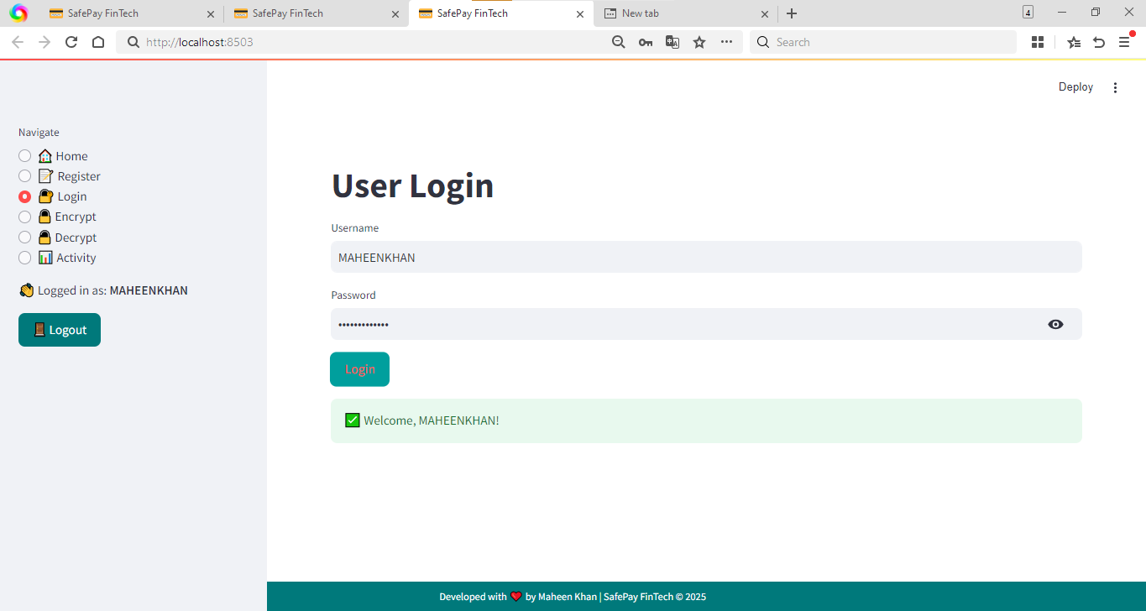

ENCRYPT PAGE
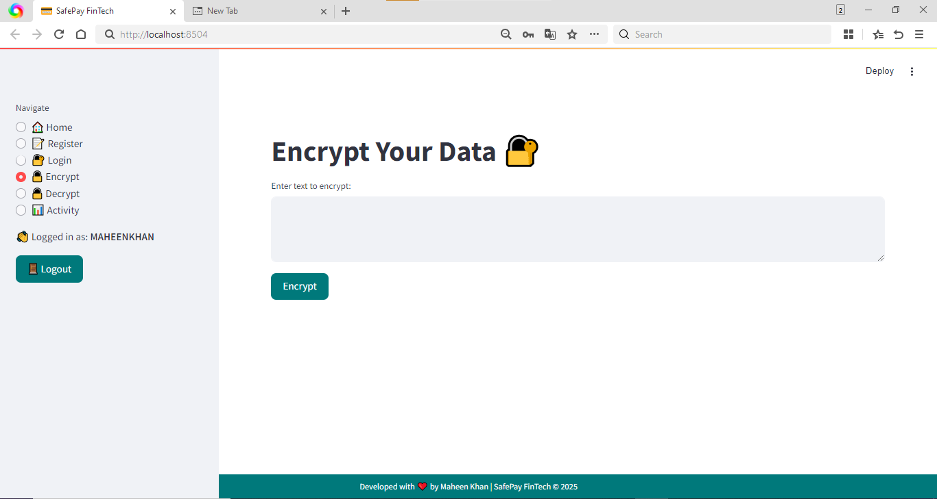
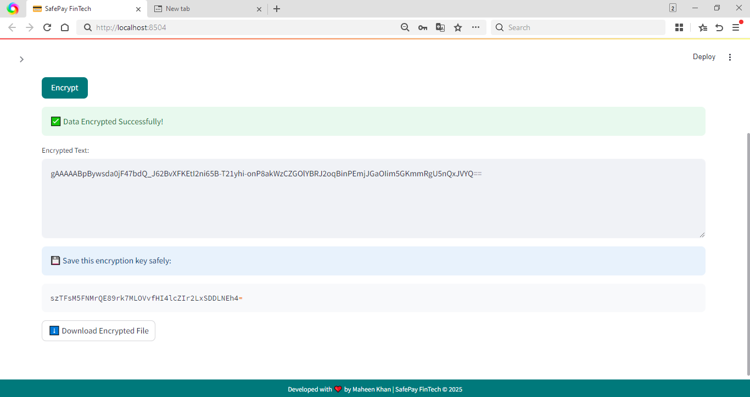

DECRYPT PAGE

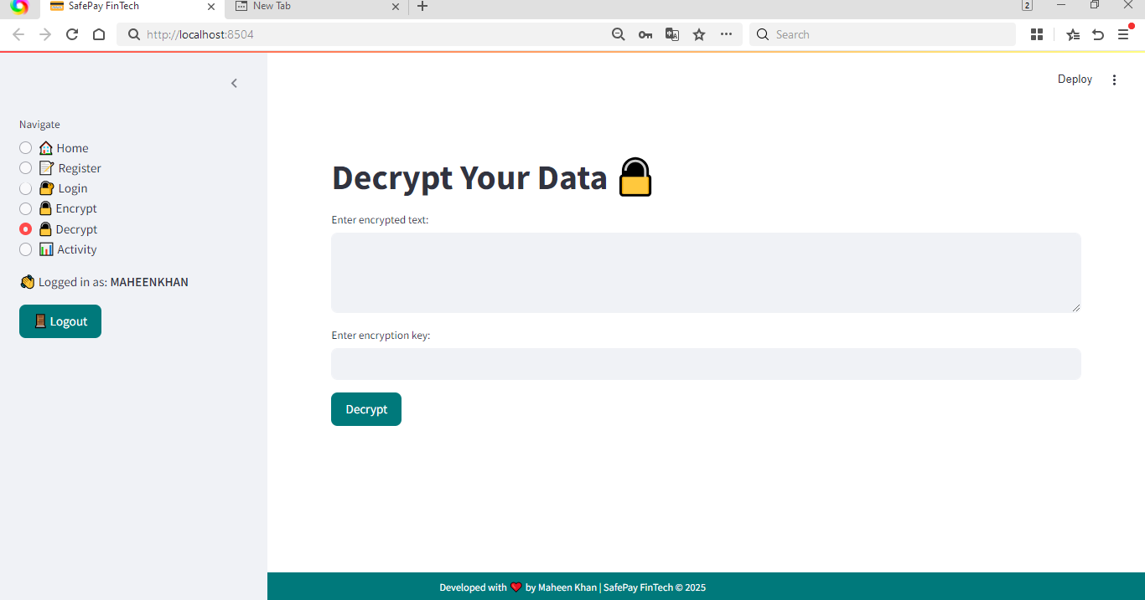

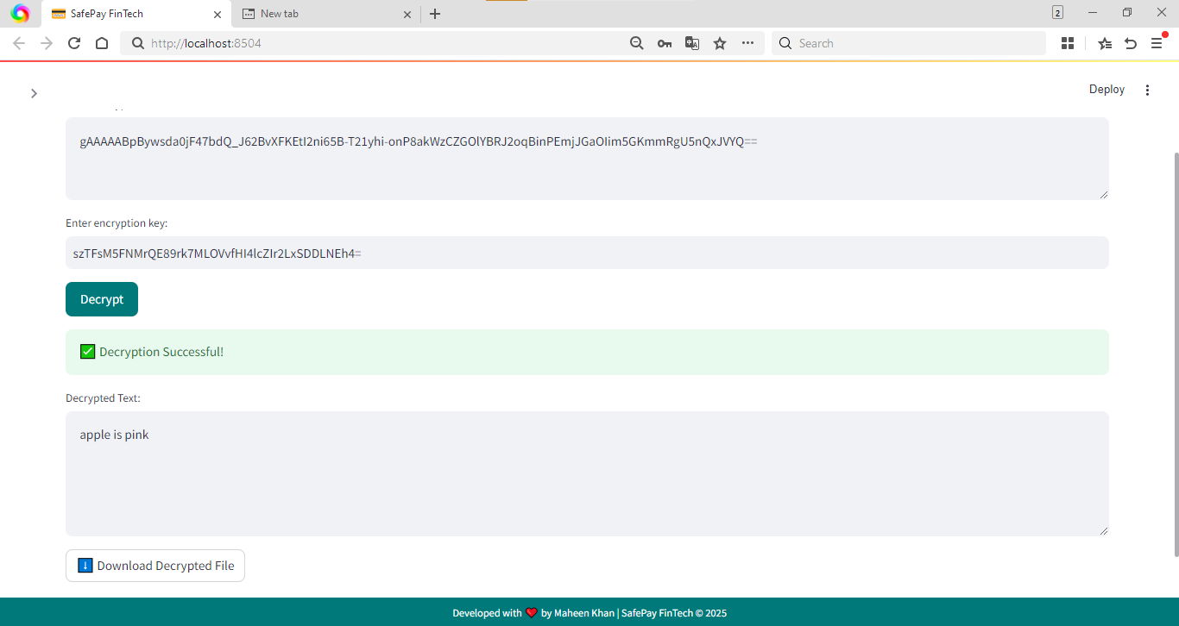

ACTIVITY PAGE

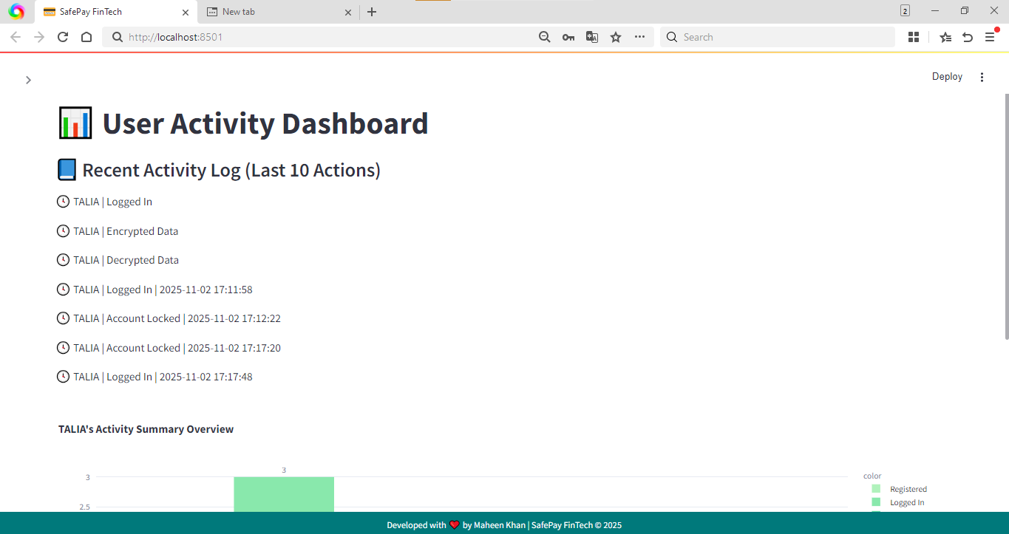
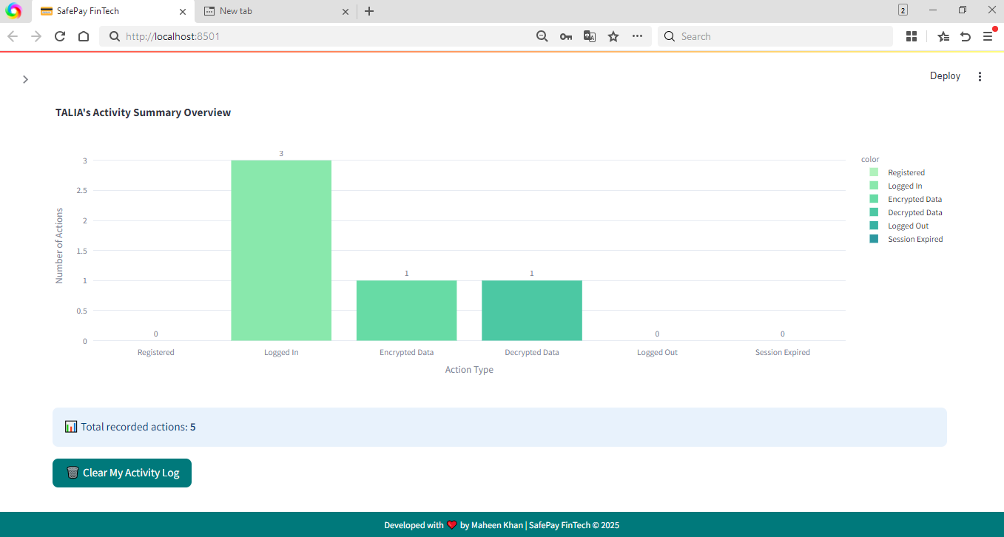

TESTING:
No. | Test Case | Action Performed | Expected Outcome | Observed Result | Pass/Fail
1 | SQL Injection | Entered 'OR 1=1-- in login username and any password | App rejects input / shows "Invalid username or password." | Error handled properly | Pass
2 | Password Strength | Tried registering with password 12345 | Registration blocked; warning about password strength | Warning shown: "Password must be at least 8 characters long and contain letters and numbers." | Pass
3 | Special Character Input | Entered <script> as username | Input sanitized or rejected; no script execution | Sanitized/displayed as text; no alert | Pass
4 | Unauthorized Access | Opened Encrypt/Decrypt/Activity without login | Redirected/blocked with login warning | Access blocked with "Please login first!" | Pass
5 | Session Expiry | Logged in, stayed idle ~5 minutes, then tried action | Session expired / required re-login | THIS FEATURE IS NOT ADD | FAIL
6 | Logout Functionality | Logged in, pressed Logout | Session destroyed; accessing protected pages redirects to login | Logged out; protected pages blocked | Pass
7 | Data Confidentiality | Opened users.txt file | Passwords are hashed/encrypted (not plaintext) | File shows encrypted password strings (not readable) | Pass
8 | File Upload Validation | Tried uploading a .exe (or wrong type) if upload exists | File rejected / not accepted | File rejected (or no upload control) | Pass
9 | Error Message Leakage | Entered invalid input to force error | App shows generic error; no stack trace or sensitive info | Generic error message shown, no stack trace | Pass
10 | Input Length Validation | Entered 5000 chars in a text field | Input rejected or safely handled; no crash | Validation triggered or app handled input safely | Pass
11 | Duplicate User Registration | Tried registering existing username | Error message shown: "Username already exists." | Error shown | Pass
12 | Number Field Validation | Entered letters into a numeric field (if exists) | Field rejects letters or shows warning | Validation successful / rejected letters | Pass
13 | Password Match Check | Mismatched confirm password during register | Registration blocked; error shown | Error: "Passwords do not match." | Pass
14 | Data Modification Attempt | Manually changed stored transaction/IDs (or edited saved files) | Unauthorized change blocked or no effect | No unauthorized change accepted | Pass
15 | Email Validation | Entered invalid email like abc@ | Registration rejected; shows email error | Validation shown / warning displayed | Pass
16 | Login Attempt Lockout | Attempt wrong password 5 times | Account locked or temp blocked | Lockout/warnings triggered (or repeated attempts warned) | Pass/Fail (state result)
17 | Secure Error Handling | Forced error (e.g., blank decrypt key / invalid input) | App handles error gracefully; no crash | Controlled message shown; app didn't crash | Pass
18 | Encrypted Record Check | Open downloaded encrypted_data.txt | Encrypted text unreadable (ciphertext) | File shows unreadable ciphertext | Pass
19 | Input Encoding | Entered emoji / Urdu text (e.g., 😊, اسلام) | App accepts and displays or handles it properly | No corruption; handled gracefully | Pass
20 | Empty Field Submission | Left required fields blank and clicked submit | Warning shown; action blocked | Warning displayed and action blocked | Pass

SCREENSHORT
- SQL INJECTION
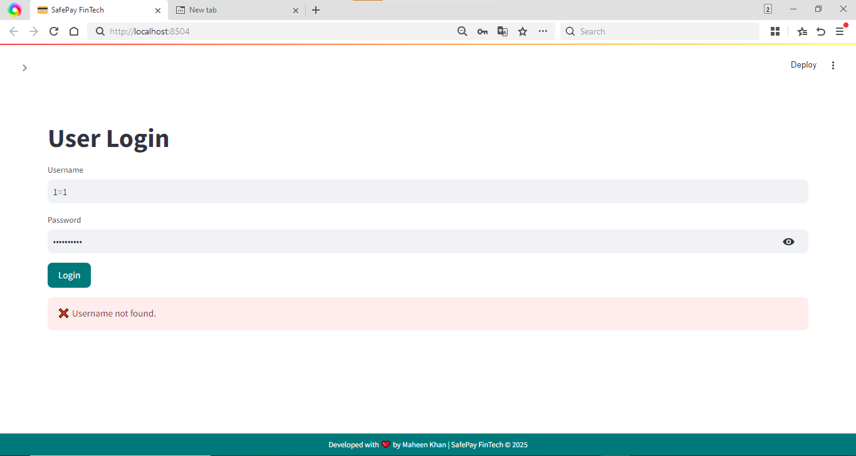
PASSWORD WEAK
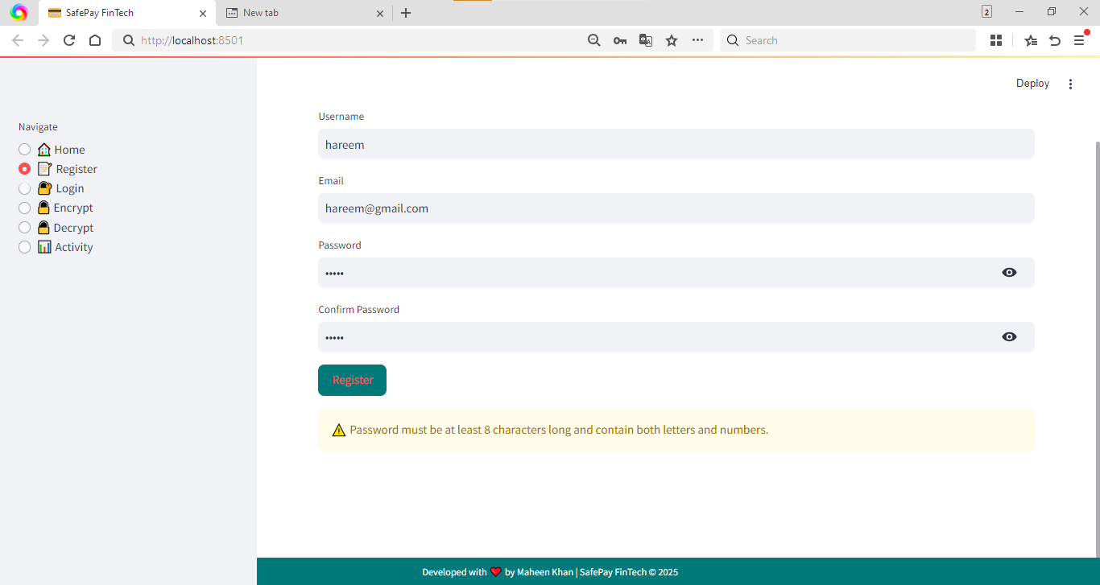
Test 3

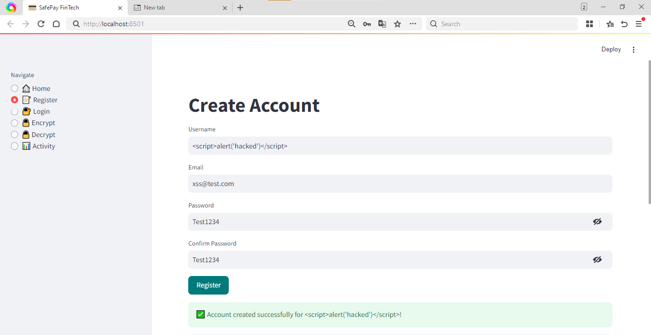
Test 4 unauthorized access
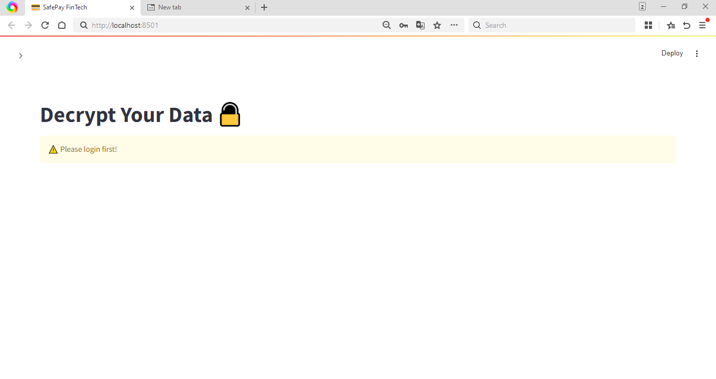

Test 5 session
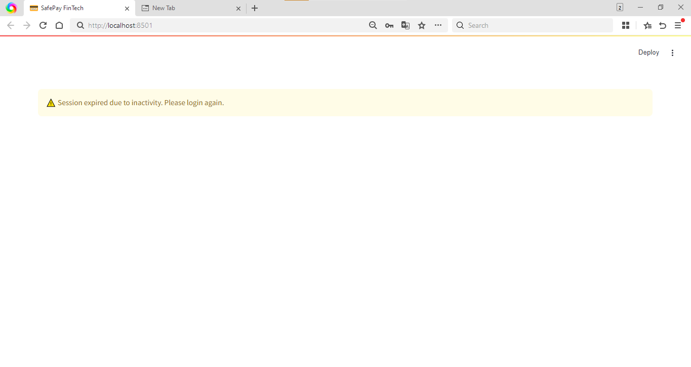

Test 6 (Logout Functionality)
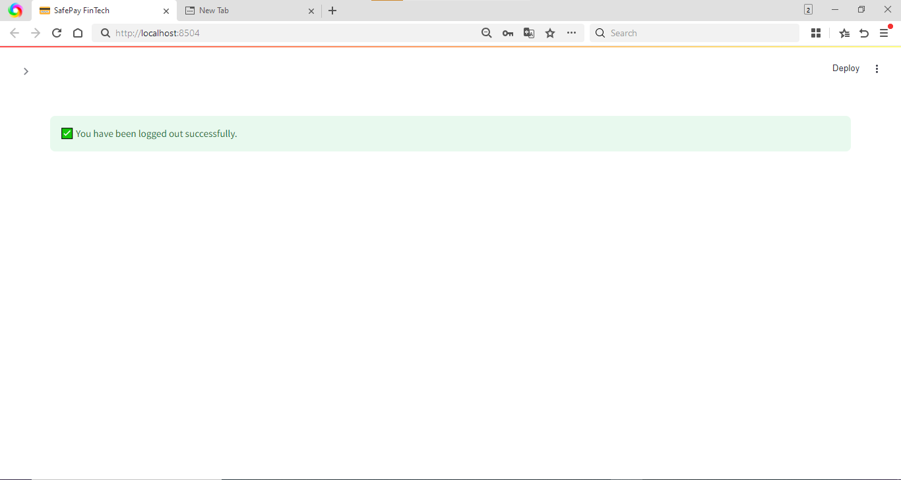

Test 7 (Data Confidentiality)
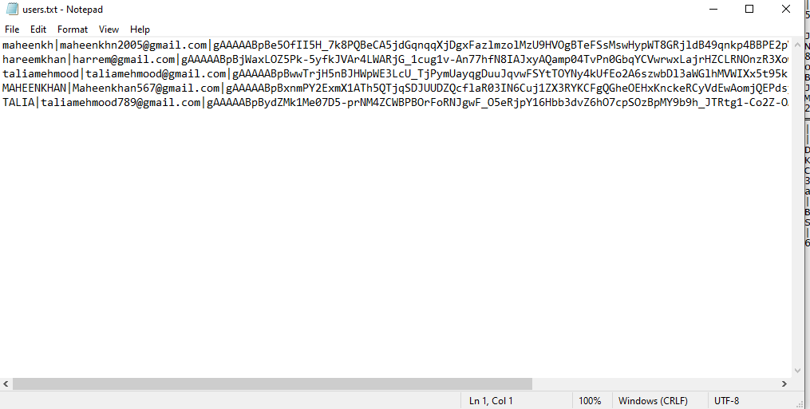

Test 8 (File Upload Validation)
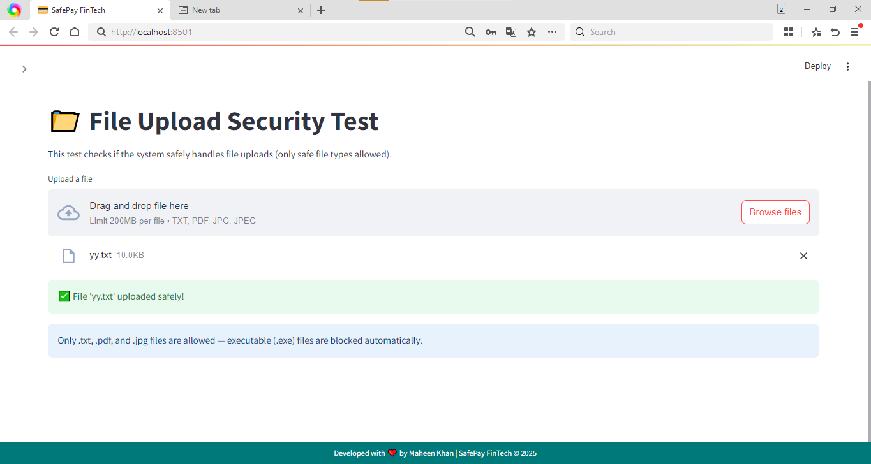

Test 9 (Error Message Leakage)
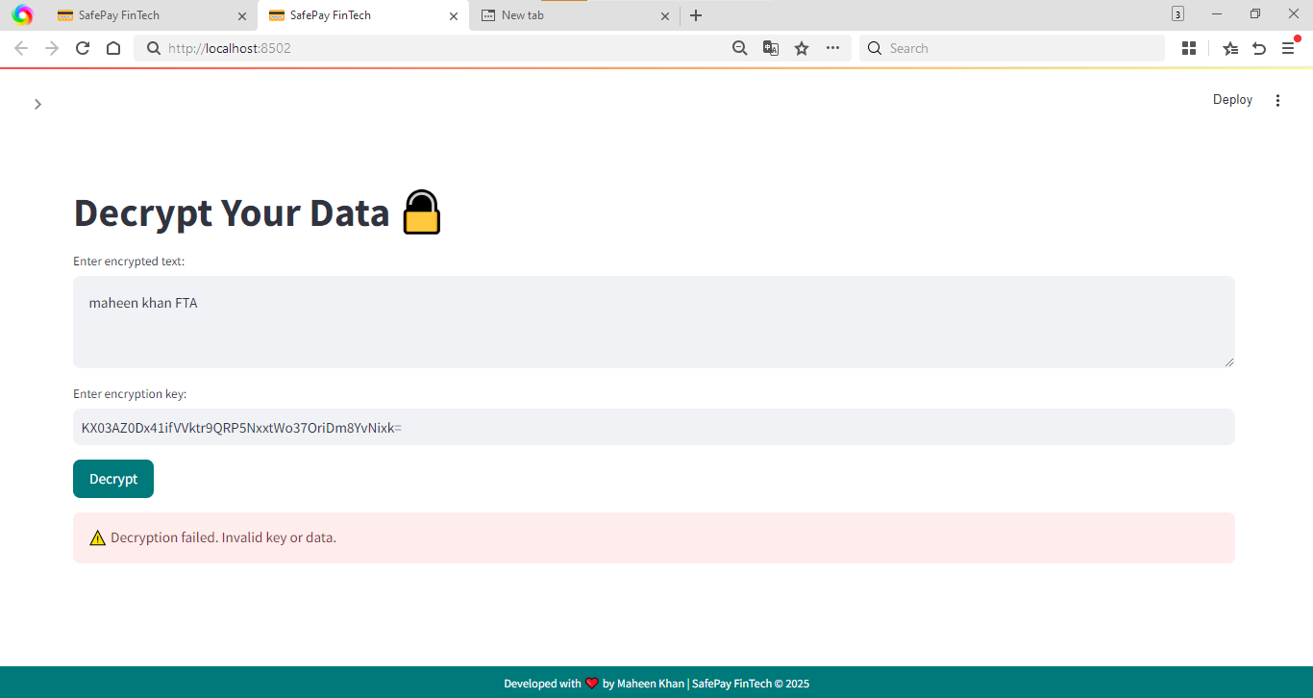

Test 10 (Input Length Validation)

Test 11: Activity Log Protection
Login 1 talia
Login 2 maheen
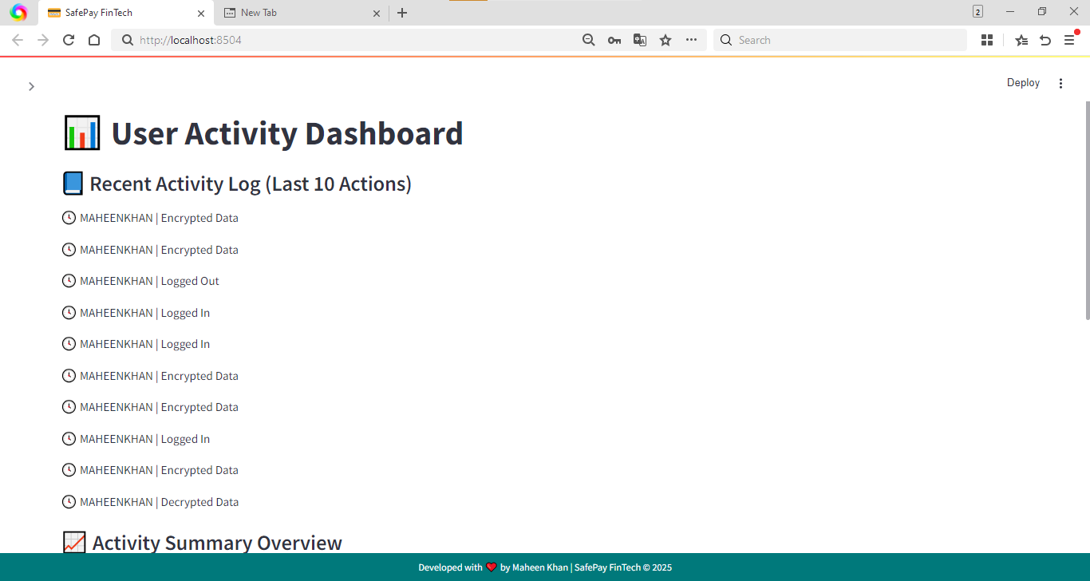
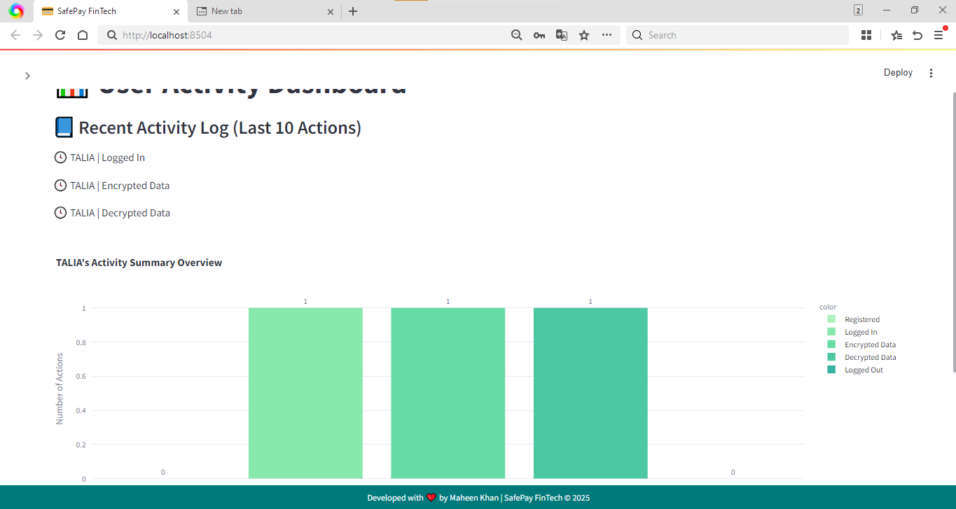

Test 12: Number Field Validation

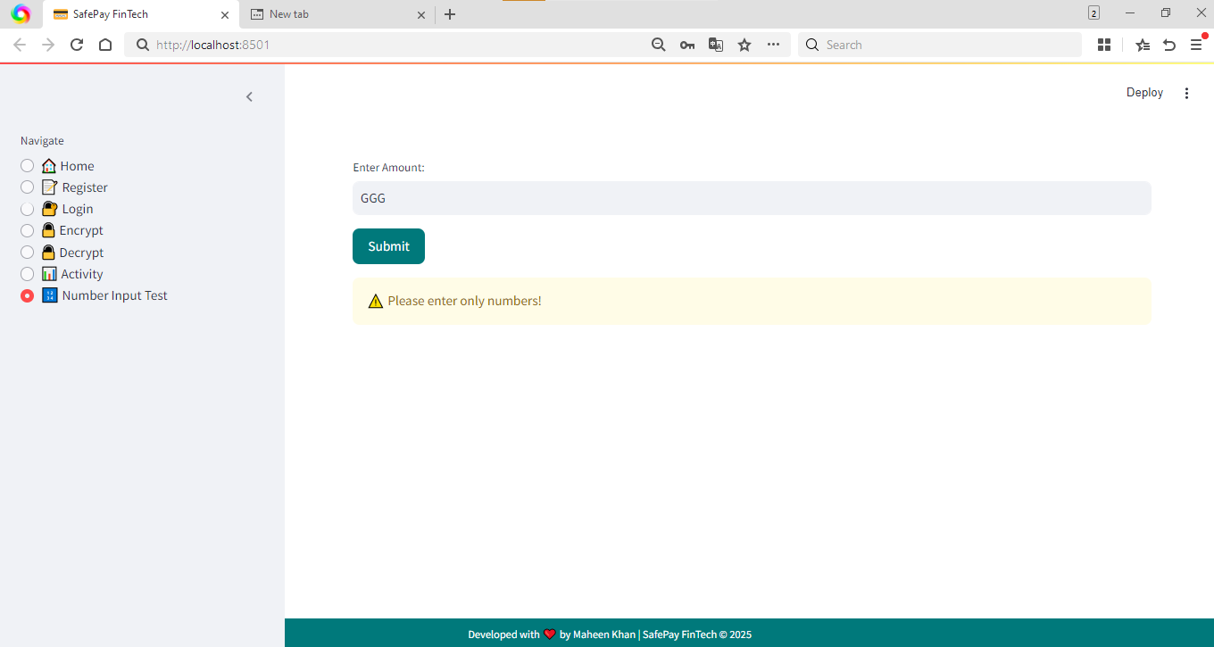

Test 13: Password Match Check
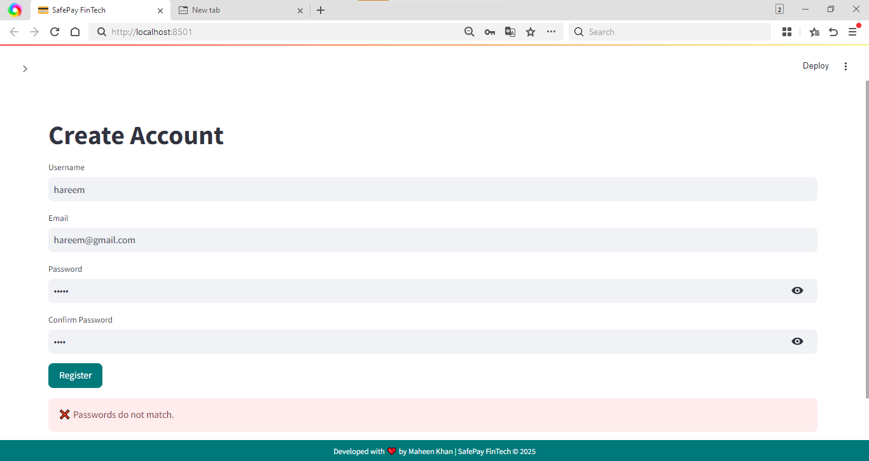
Test 14: Data Modification Attempt
Before the changes

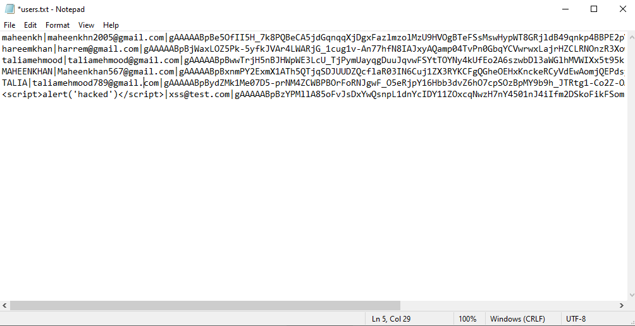
After the changes (Maheenkh)
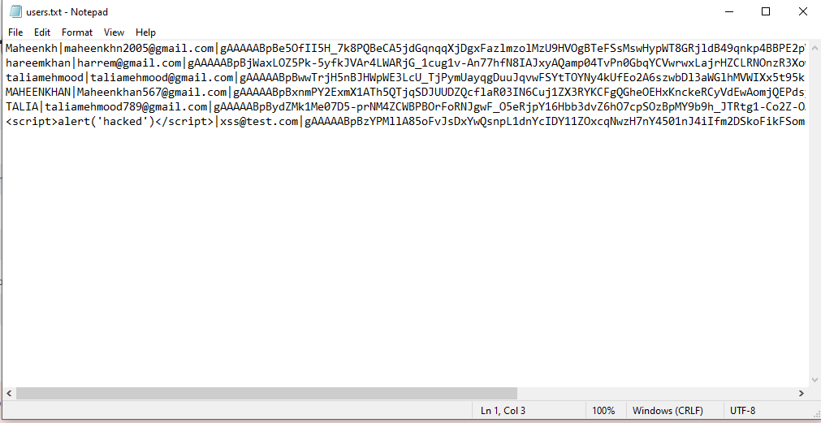
Test 15 – Email Validation
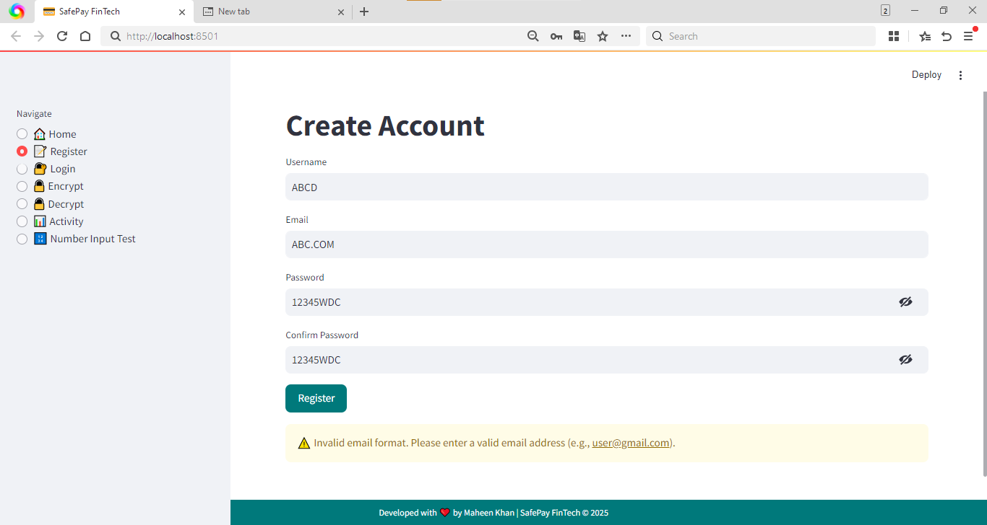
Test 16 – Login Attempt Lockout (Brute Force Protection)
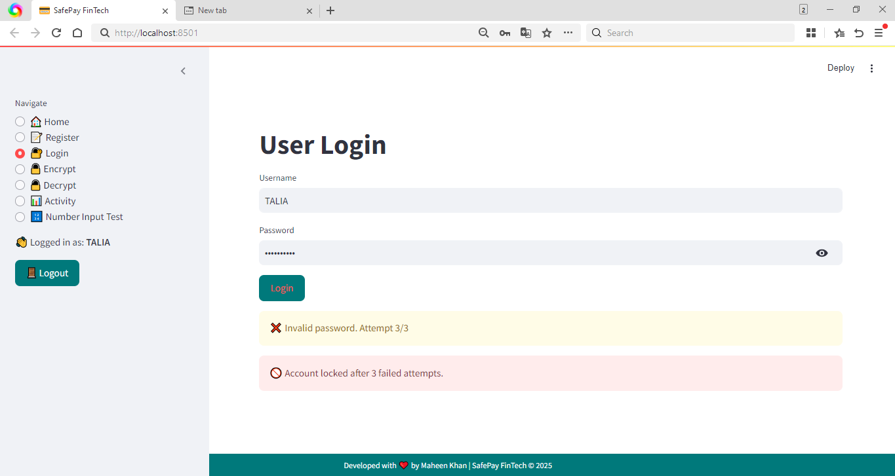

Test 17 – Secure Error Handling

TEST 18 – Failed Login Attempts & Account Lock

TEST 19 – Successful Login After Lock Reset
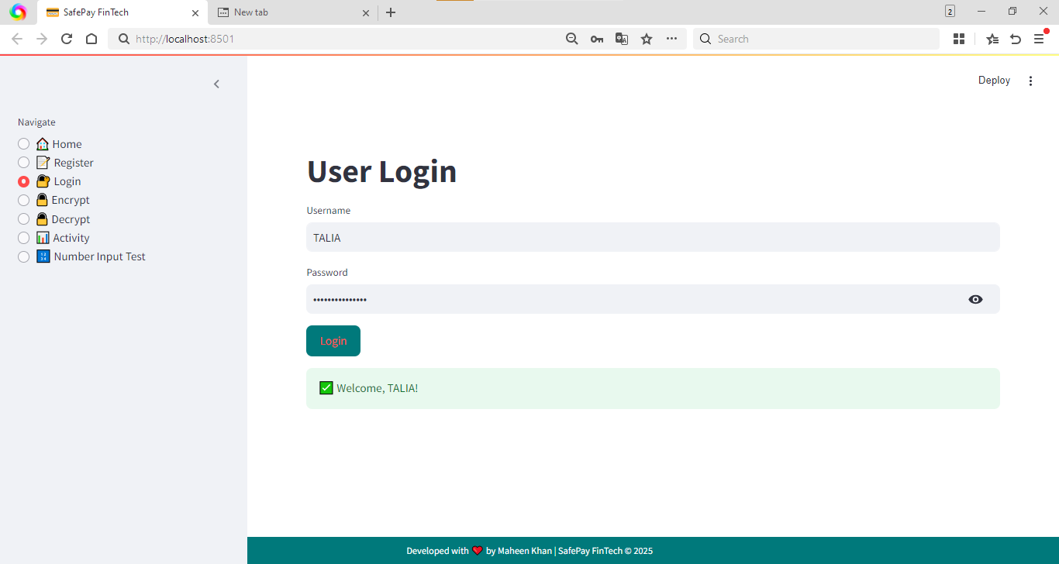

TEST 20 – Activity Log Validation

